Introduction to TIG Welding Aluminium
Brief Reference Guide:

Material Properties.

Melting Point = 660 Degrees C
Oxide Layer Melting Point = 2072 Degrees C

Aluminium is a non magnetic, relatively soft, durable, lightweight, ductile and malleable metal with appearance ranging from silvery to dull gray. It is a good thermal and electrical conductor and has excellent corrosion resistance, due to the thin layer of aluminium oxide that forms on the surface. The properties of pure aluminium are improved by alloying the base material with other elements such as Silicone and Magnesium.

The oxide layer In aluminium is also what gives the material its relatively high strength in relation to its weight and also provides good corrosion resistance. However, the large difference in melting point between the base material and this oxide layer makes welding of the material more awkward. Aluminium alloys fall into 2 broad catagories. Those that are heat treatable, and those that are not. Heat treatable alloys can have the material characteristics modified by different applications of heat. Non heat treatable alloys can only be modified by cold working.

Aluminium types.
Alloy Series/  Weldability | Type | Main Alloying Elements
1000 series  Weldable | Non Heat Treatable | Pure aluminum
2000 series  Non Weldable | Heat Treatable | Aluminum and copper. (High strength aluminum used in the aerospace industry )
3000 series  Weldable | Non Heat Treatable | Aluminum and manganese. (Low- to medium-strength alloys, examples of products using these alloys are beverage cans and refrigeration tubing)
4000 series  Weldable | Non Heat Treatable | Aluminum and silicon. (Most alloys in this series are either welding or brazing filler materials)
5000 series  Weldable | Non Heat Treatable | Aluminum and magnesium. (These alloys are used primarily for structural applications in sheet or plate metals - all 5000 series alloys are weldable )
6000 series  Weldable | Heat Treatable | Aluminum, magnesium and silicon. (These alloys are heat treatable and commonly used for extrusions, sheet and plate - all are weldable, but can be crack sensitive. Never try to weld these alloys without using filler metal)
7000 series  Non Weldable | Heat Treatable | Aluminum and zinc. (These are high strength aerospace alloys that may have other alloying elements added)

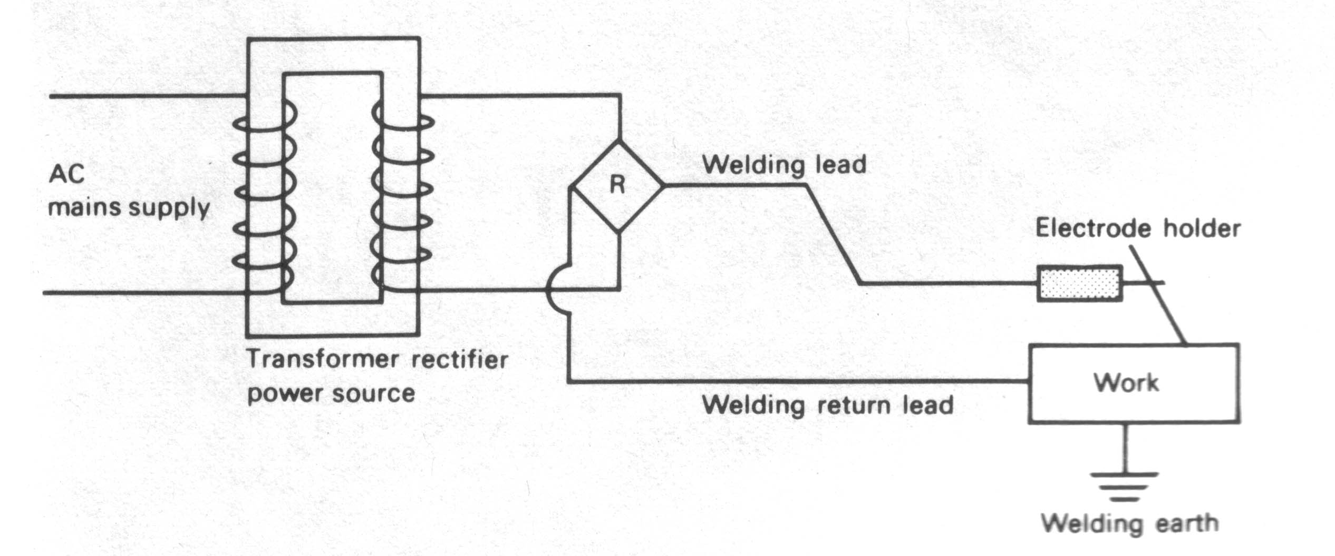

Procedure

Touching the electrode on the work and then withdrawing it, to approximately 3 to 6 mm from the work is the technique used to start the arc. When the electrode touches the work a Current flows, and when it is withdrawn from the work the current continues to flow in the form of a spark or arc across the gap just formed. The arc temperature is approximately 4000 °C the metal is transferred across the arc from the electrode to the molten pool in small Globules, which when using covered electrodes, are coated with molten Flux which floats on the top of weld as the globules enter the
Welding Process

Preparation.

Preparation
It is essential that the material is as clean as possible. Clean with a degreaser. DO NOT USE BRAKE CLEANER OR ANY OTHER PRODUCT THAT CONTAINS Tetrachloroethylene. This chemical when heated creates Phosgene, which can be fatal in a single breath. Check the safety label on the product before use.
Mechanically clean the parts to be welded with a stainless steel or brass wire brush that has not been used for any other purpose.

Setup
TIG welding aluminium is done using AC. As the current alternates between the negative and positive half cycles, a cleaning effect occurs on the positive half cycle. This helps to remove the oxide layer. This positive half cycle also concentrates heat on the electrode and not on the job, so welding is a balancing act between cleaning, penetration, arc focus and electrode condition.

Electrode Preparation
Using a 2% Zirconiated or pure Tungsten electrode, grind the electrode tip to a 45 degree tip with a small flat at the end. “Ball up” the electrode end on a piece of scrap. Strike the arc and hold the electrode vertical for a few moments while a small ball forms on the end of the electrode. Set post gas flow to a considerable amount of seconds to allow the electrode to cool before it is exposed to air. The “ball” on the end should be shiny, not black or sooty looking. The ball should not be wider than the electrode diameter.

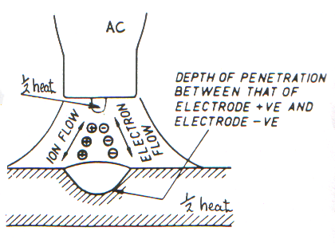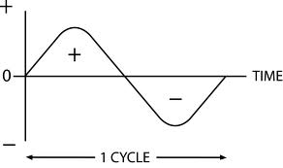
AC Wave Balance Control
Modern welding machines allow adjustment of the positive and negative half cycles. Usually expressed as a percentage of the negative half cycle. For example, AC wave balance set to 75 gives 75% negative (penetration), and 25% positive (cleaning).

AC Frequency Control
Normal AC from the mains is 50hz in the UK, but modern welders allow the adjustment of this frequency, usually from 50 – 150 hz but sometimes even up to 400hz. Increasing the frequency allows for a tighter arc and the ability for the electrode to hold a sharper point. Useful for welding thinner material or joints requiring tight beads. Lower frequency gives a broader arc with better penetration.

Process
Strike the arc and watch for the surface layer to become shiny. Aluminium does not glow red like steel so there is no indication of when it is melting.
Welding should be performed with the electrode held as near to vertical as possible. Incorrect electrode angle will result in “blobs” forming on the filler rod before it is introduced to the weld puddle.
Watch the white area around the weld bead. This is the cleaning action. Too much cleaning may result in a large white area and a balled up or destroyed electrode. To little and dirt and oxide will be evident on the weld bead. If the electrode tip “wobbles” ie it literally moves about, it is near capacity and you should go up an electrode size.

